Quantum Computation with Quasiparticles of
the Fractional Quantum Hall Effect

D. V. Averin and V. J. Goldman
Dept. of Physics, State University of New York, Stony Brook,
NY 11794-3800, U.S.A.

1. Introduction

"Topological" quantum computation with anyons has been suggested as a way of implementing intrinsically fault-tolerant quantum computation.¹⁻⁴ The inter-twining of anyons, quasiparticles of a two-dimensional electron system (2DES) with nontrivial exchange statistics, induces unitary transformations of the system wavefunction that depend only on the topological order of the underlying 2DES. These transformations can be used to perform quantum logic, the topological nature of which is expected to make it more robust against environmental decoherence. The aim of this work is to propose a specific and experimentally feasible approach for implementation of the basic elements of the anyonic quantum computation using adiabatic transport of the fractional quantum Hall effect (FQHE) quasiparticles in systems of quantum antidots.⁵
An antidot is a small hole in the 2DES produced by electron depletion, which localizes FQHE quasiparticles at its boundary due to the combined action of the magnetic field and the electric field created in the depleted region. If the antidot is sufficiently small, the energy spectrum of the antidot-bound quasiparticle states is discrete, with finite excitation energy Δ. When Δ is larger than the temperature kT, modulation of the external gate voltage can be used to attract quasiparticles one by one to the antidot.^{5,6} In this regime multi-antidot systems can be used to perform quantum logic based on the adiabatic manipulation of individual quasiparticles.

2. FQHE qubits

In analogy to Cooper-pair qubits,⁷⁻⁹ information in FQHE qubits of this type can be encoded by the position of a quasiparticle in the system of two antidots. The FQHE qubit, illustrated in Fig. 1, is then the double-antidot system gate-voltage tuned near the resonance, where the energy difference ε between the quasiparticle states localized at the two antidots is small, ε << Δ. At energies smaller than Δ, the dynamics of such a double-antidot system is equivalent to the dynamics of a common two-state system (qubit). The quasiparticle states localized at the two antidots are the |0⟩ and |1⟩ states of the computational basis of this qubit. The gate electrodes of the structure can be designed to control separately the energy difference ε and the tunnel coupling Ω of the resonant quasiparticle states.
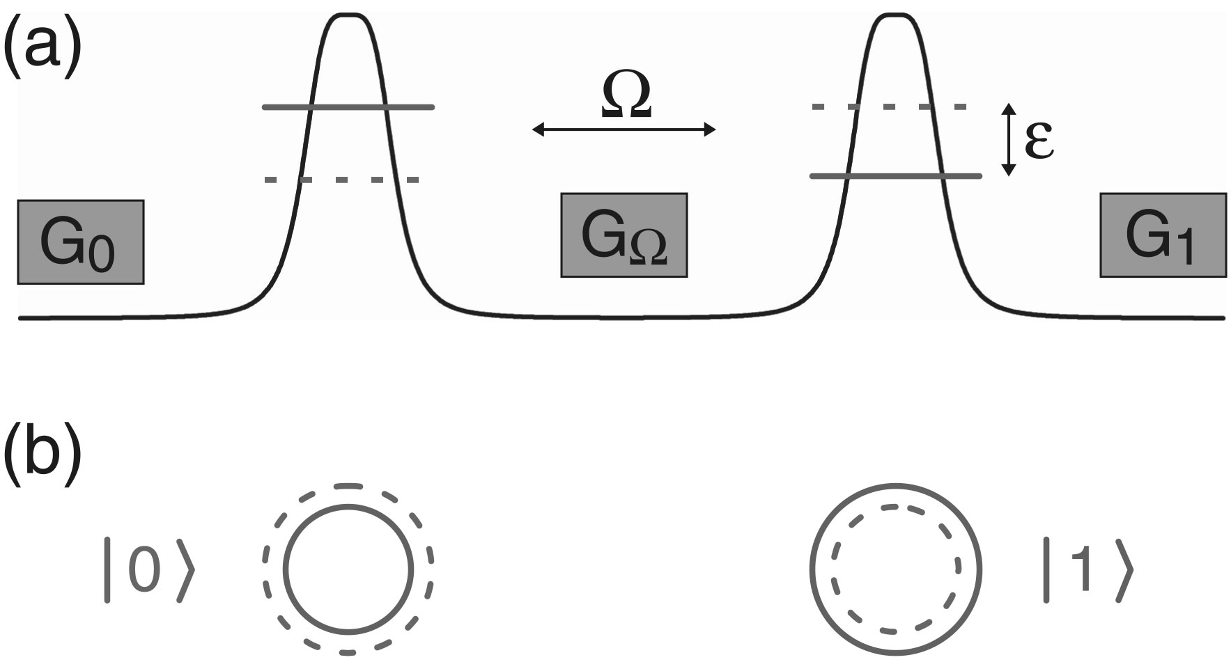

Figure 1. Schematic energy profile (a) and structure (b) of the double antidot FQHE qubit. Solid (dashed) horizontal lines in (a) indicate the edges of the incompressible electron liquid when the quasiparticle is localized at the left (right) antidot. Displacement of the electron liquid is quantized due to quantization of the single-particle states circling the antidots. Dashed rectangles in (a) are the gate electrodes controlling the energies of the antidot-bound states (G_{0,1}) and their tunnel coupling (G_{Ω}).

3. FQHE logic gates

The most natural approach to the construction of two-qubit gates with the FQHE qubits is to use fractional statistics^{10,11} of the FQHE quasiparticles. Due to fractional statistics, intertwining of the two quasiparticle trajectories in the course of time evolution of the two qubits realizes controlled-phase transformations with nontrivial values of the phase. The precise result of this operation depends on the nature of the FQHE state. In this work, we discuss the most basic and robust Laughlin state with the filling factor ν = 1/m = 1/3, where the quasiparticles have abelian statistics and the intertwining of trajectories leads to multiplication of the state wavefunction by the phase factor e^{±2πi/3}. The sign of the phase depends on the direction of the magnetic field and the direction of rotation of one quasiparticle trajectory around the other.
A possible structure of the controlled-phase gate is shown in Fig. 2. Each of the columns of four antidots contains two qubits, and the arrows denote trajectories of quasiparticle transfer through the system. The transfer leads to the transformation of the quantum state of the two qubits and its shift from the gate input (left column in Fig. 2) to the output (right column). The quasiparticle transfer can be achieved by standard adiabatic level-crossing dynamics. If a pair of antidots is coupled by the tunnel amplitude Ω, a gate voltage-induced variation of the energy difference ε through the value ε = 0 (slow on the time scale Ω⁻¹) leads to the transfer of a quasiparticle between these antidots. Correct operation of the

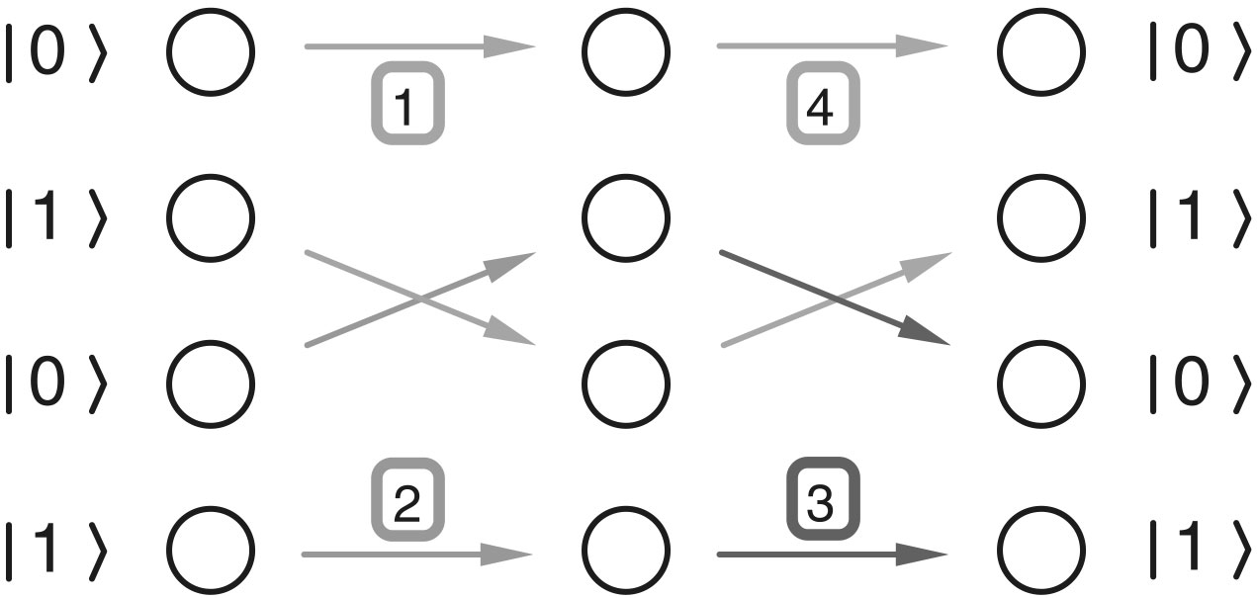

Figure 2. Antidot implementation of the two-qubit controlled-phase gate. The states |0⟩ and |1⟩ are the computational basis states of the two qubits. The arrows show the quasiparticle transfer processes for each basis state during the gate operation. The arrow numbering denotes the time sequence of these processes.

controlled-phase gate in Fig. 2 requires that the gate voltage pulses applied to the antidots are timed so that the state of the upper qubit is propagated at first halfway through the gate, then the state of the lower qubit is propagated through the whole gate, and finally the state of the upper qubit is transferred to the output. In this case, if the quasiparticle of the upper qubit is in the state |1⟩, trajectories of the quasiparticle propagation in the lower qubit encircle this quasiparticle, and the two states of the lower qubit acquire an additional phase difference ±2π/3, conditioned on the state of the upper qubit. We take the direction of magnetic field to be such that the state |1⟩ of the lower qubit acquires a positive extra phase 2π/3. Assuming that the parameters of the driving pulses are adjusted in such a way that the dynamic phases accumulated by the qubit states are integer multiples of 2π, the transformation matrix P of the gate can be written as
P = diag [ 1, 1, 1, e^{2πi/3} ] (1)
in the basis of the four gate states |00⟩, |01⟩, |10⟩, |11⟩.
The controlled-phase gate P, given by Eq. (1), combined with the possibility of performing arbitrary singe-qubit transformations, is sufficient for universal quantum computation. To demonstrate this explicitly, we construct a combination of the P gate with single-qubit gates that reproduces the usual controlled-not (c-not) gate C. The c-not gate is known to be sufficient for universal quantum computation.¹² Since the gates P and C are not equivalent with respect to single-qubit transformations, two applications of P are required to reproduce C.¹³ To find appropriate single-qubit transformations that should complement the two P gates, it is convenient to first reduce P to the conditional z-rotation R of the second qubit through angle −π/3: R = diag [ 1, 1, e^{-πi/3}, e^{πi/3} ]. We notice that R = S(−π/3)P, where S(α) is an unconditional shift of the phase of the state |1⟩ of the first qubit by α. After this reduction, it is straightforward to find the necessary single-qubit transformations from the requirements that the state of the first qubit is unchanged by C, while the conditional action of C on the second qubit is given by the Pauli matrix σ_{x}. These two requirements do not specify the necessary transformations uniquely. One possible choice is to use the transformations that correspond physically to modulation of the tunnel coupling between the states of the second qubit (i.e., involve only matrices σ_{x}, σ_{y}). In this case, we obtain
C = S(π/2) (U₋)† S(−π/3) P U₋ U₊ S(−π/3) P (U₊)† , (2)
where U± = [1]₁ ⊗ [exp{−iϕ(σ_{x} ± σ_{y})/√2}]₂. Here the subscripts 1, 2 denote the part of the transformation acting on the first and the second qubit, respectively, and the rotation angle ϕ is given by the condition cos(2ϕ) = 1/√3, 0 ≤ ϕ ≤ π/2. Physically, the transformations S can be implemented as pulses of the gate voltage applied to the antidot |1⟩ of the first qubit, while the U's represent pulsed modulation of the amplitude of the tunnel coupling between the two antidots of the second qubit that keeps the phase of this coupling fixed.

4. Decoherence mechanisms

As the next step, we analyze decoherence mechanisms in the antidot qubits. At low temperatures, the energy gap in the FQHE liquid exponentially suppresses quasiparticle excitations in the bulk of the sample. Due to this suppression only sample edges and external metallic gate electrodes support low energy excitations that can give rise to dissipation and decoherence. A qubit is coupled to both the gate electrodes and the edges by the Coulomb interaction. The charge q of the qubit quasiparticle (q = e/m, where m is an odd integer for the primary Laughlin FQHE liquids) induces a polarization charge on the gate electrodes that fluctuates in the course of qubit time evolution. The current thus induced in the electrodes with finite resistance R leads to energy dissipation and decoherence. This decoherence mechanism associated with the "electromagnetic environment" of the structure (see, e.g., Ref. 14) is generic for most of the solid state qubits. In the FQHE qubits its strength should be lower than in other charge-based qubits, due to the smaller charge of the FQHE quasiparticles. Indeed, if the gate electrode is close to an antidot (on the scale of the distance d between the two qubit antidots), the amplitude of the variations of the induced charge is roughly equal to the quasiparticle charge q. In this "worst case" scenario, the limitation on the quality factor of qubit dynamics introduced by the gate electrode is equal to e²R/m², and is on the order of 10⁻³ for realistic values of the resistance R and for the m = 3 qubits considered in this work. Optimization of the gate structure of the qubit should further reduce the strength of this type of decoherence by reducing electrostatic gate-qubit coupling.
The Coulomb interaction also couples qubit dynamics to edge excitations of the FQHE liquid. The edge supports one-dimensional (1D) chiral plasmon modes¹⁵ propagating with velocity v. In the situation of interest here, when the qubit-edge distance L is much larger than the qubit size d, the coupling operator V can be expressed directly in terms of the 1D density of charge ρ(x) carried by plasmon modes: V = σ_{z} ∫dxU(x)ρ(x). In this expression, σ_{z} represents the position of the quasiparticle on one or the other antidot of the qubit, and U(x) is the variation (with the quasiparticle position) of the electrostatic potential created by the qubit at point x along the edge. A representative estimate of the dissipation/decoherence rate introduced by this coupling is given by the decay rate Γ of the excited antisymmetric superposition of the antidot states. Assuming that the qubit dipole is perpendicular to a straight edge, and that the electric field is not screened between the edge and the qubit, we can evaluate Γ directly:
Γ = (d/L)² (e²/4πκv)² (Ω/4πm³) exp[–LΩ/v] (3)
where κ is the material dielectric constant. This equation shows that the edge-related limitation Γ/Ω on the qubit quality factor can vary widely, depending on the system geometry and qubit energy parameters. For a realistic set of numbers: κ ≈ 10, v ≈ 10⁵ m/s, Ω ≈ 0.1 K, d ≈ 100 nm (see discussion below), we obtain Γ/Ω ≈ 10⁻³ for the edge that is L ≈ 3 μm away from the qubit.
To evaluate qubit parameters we summarize the basic set of requirements necessary for correct operation of the FQHE qubits and gates described above as kT << ε and Ω << Δ. The antidot excitation energy Δ is estimated as Δ ≈ u/r, where r is the antidot radius and u ≈ 10⁴–10⁵ m/s is the velocity of quasiparticle motion around the antidot.¹⁶ This estimate means that at a temperature T = 0.05 K the radius r should be smaller than 100 nm. Since the tunnel coupling Ω decreases rapidly with the tunneling distance s between the antidots, Ω ∝ exp[−eBs²/12],¹⁷ the fact that Ω should be at least larger than T means that s should not exceed a few magnetic lengths l_{B} = (/eB)^{1/2} ~ 10 nm for typical values of the magnetic field B. Although these requirements on the radius r and antidot spacing s can be satisfied with present-day fabrication technology, they present a formidable challenge. It should be noted that these requirements are not specific to our FQHE scheme, but characterize all semiconductor solid-state qubits based directly on the quantum dynamics of individual quasiparticles, and not collective degrees of freedom (as used, e.g., in the case of superconductors).

5. Conclusions

We believe that the fabrication challenges facing FQHE qubits are well compensated by the advantages of the FQHE approach. First among these advantages is the energy gap of the FQHE liquid that suppresses quasiparticle excitations and the associated decoherence in the bulk of the 2DES, and allows control of the remaining sources of decoherence through the system layout – see the discussion above. The second advantage is the topological nature of statistical phase that makes it possible to entangle qubits without their direct dynamic interaction. This possibility should lead to simpler design of the FQHE quantum logic circuits in comparison to other solid-state qubits, where control of the qubit-qubit interaction typically presents a difficult problem.

Acknowledgments

This work was supported in part by the NSA and ARDA under an ARO contract.

References

1. A. Yu. Kitaev, "Fault-tolerant quantum computation by anyons," quant-ph/9707021.
2. J. Preskill, "Fault-tolerant quantum computation", in: H.-K. Lo, S. Papesku, and T. Spiller, eds., Introduction to Quantum Computation and Information, Singapore: World Scientific, 1998, pp. 213-269.
3. S. Lloyd, "Quantum computation with abelian anyons," quant-ph/0004010.
4. M. H. Freedman, A. Yu. Kitaev, M. J. Larsen, and Z. Wang, "Topological quantum computation," quant-ph/0101025.
5. V. J. Goldman and B. Su, "Resonant tunneling in the quantum Hall regime: measurement of fractional charge," Science 267, 1010 (1995).
6. I. J. Maasilta and V. J. Goldman, "Tunneling through a coherent quantum antidot molecule," Phys. Rev. Lett. 84, 1776 (2000).
7. D. V. Averin, "Adiabatic quantum computation with Cooper pairs," Solid State Commun. 105, 659 (1998).
8. Yu. Makhlin, G. Schon, and A. Shnirman, "Josephson-junction qubits with controlled couplings," Nature 398, 305 (1999).
9. Y. Nakamura, Yu. A Pashkin, and J. S. Tsai, "Coherent control of macroscopic quantum states in a single-Cooper-pair box," Nature 398, 786 (1999).
10. B. I. Halperin, "Statistics of quasiparticles and the hierarchy of fractional quantized Hall states," Phys. Rev. Lett. 52, 1583 (1984).
11. D. Arovas, J. R. Schrieffer, and F. Wilczek, "Fractional statistics and the quantum Hall effect," Phys. Rev. Lett. 53, 722 (1984).
12 A. Barenco, C. H. Bennett, R. Cleve, D. P. DiVincenzo, N. Margolus, P. Shor, T. Sleator, J. A. Smolin, and H. Weinfurter, "Elementary gates for quantum computation," Phys. Rev. A 52, 3457 (1995).
13. Yu. Makhlin, "Nonlocal properties of two-qubit gates and mixed states and optimization of quantum computation," quant-ph/0002045.
14. G. L. Ingold and Yu. V. Nazarov, "Charge tunneling rates in ultrasmall junctions," in: H. Grabert and M. Devoret, eds., Single Charge Tunneling, New York: Plenum, 1992, pp. 21-107.
15. X. G. Wen, "Theory of the edge states in fractional quantum Hall effects," Int. J. Mod. Phys. B 6, 1711 (1992).
16. I. J. Maasilta and V. J. Goldman, "Energetics of quantum antidot states in the quantum Hall regime," Phys. Rev. B 57, R4273 (1998).
17. A. Auerbach, "Comparison of tunneling rates of fractional charges and electrons across a quantum Hall strip," Phys. Rev. Lett. 80, 817 (1998).

